# Introduction to Analysis

# Analysis Methodology

# Feasibility Study

# Software Requirement Specification

## Functional Requirements

|  |  |  |  |  |
| --- | --- | --- | --- | --- |
| Req.ID | Title | Description | Purpose | Dependences |
| FR1 | User Authentication | Assigning privileges as per the user’s authority | Security and integrity against a particular user’s action. | N/A |
| FR2 | Add course | Addition of new course by the authority | Including new trends and practices | **FR1** |
| FR3 | Update course | Update the contents of an existing course | Keeping up with the latest contents. | **FR2** |
| FR4 | Delete course | Delete the contents of an existing course | Excluding unwanted additions | **FR2** |
| FR5 | Display available course | Exhibit existing courses to the user | Interact and assimilate contents of an existing course | **FR1** |
| FR6 | Post comments on course | Leave comments on an existing course | Comment about additional queries and answers. | **FR1** |
| FR7 | Update comment | Update an existing comment | Edit or alter existing comment | **FR1** |
| FR8 | Delete comment | Delete an existing comment | Delete unwanted comments | **FR1** |
| FR9 | View comment | Display and read comments on courses | Display and read comments | **FR1** |
| FR10 | Create user profile | Create new learner profile | To save the details and progress of user | **FR1** |
| FR11 | Delete user profile | Delete existing user | Delete existing user | **FR1** |
| FR12 | Edit user profile |  |  | **FR1** |
| FR13 | Display user details |  |  | **FR1** |
| FR14 | Mark course as completed |  |  | **FR1** |
| FR15 | Unmark course as completed |  |  | **FR1** |
| FR16 | Blog CMS |  |  | **FR1** |
| FR17 | Repot issues |  |  | **FR1** |
| FR18 | View reported issues |  |  | **FR1** |
| FR19 | Delete reported issues |  |  | **FR1** |
| FR20 | Feedback CMS |  |  | **FR1** |
| FR21 | Request courses |  |  | **FR1** |
| FR22 | View requested courses |  |  | **FR1** |
| FR23 | Delete requested courses |  |  | **FR1** |

## Non-Functional Requirements

|  |  |  |
| --- | --- | --- |
| Req.ID | Category | Description |
| NFR1 | Modifiability |  |
| NFR2 | Interface |  |
| NFR3 | Usability |  |
| NFR4 | Flexibility |  |
| NFR5 | Interoperability |  |
| NFR6 | Security |  |
| NFR7 | Performance |  |
| NFR8 | Data integrity |  |
| NFR9 | Modularity |  |
| NFR10 | Scalability |  |
| NFR11 | Load and Concurrency |  |

## MoSCoW Prioritization

|  |  |  |  |
| --- | --- | --- | --- |
| Req.ID | Requirement | MoSCoW | Justification |
| NFR1 | Modifiability |  |  |
| NFR2 | Interface |  |  |

# Use Case Diagram

## Login and Registration

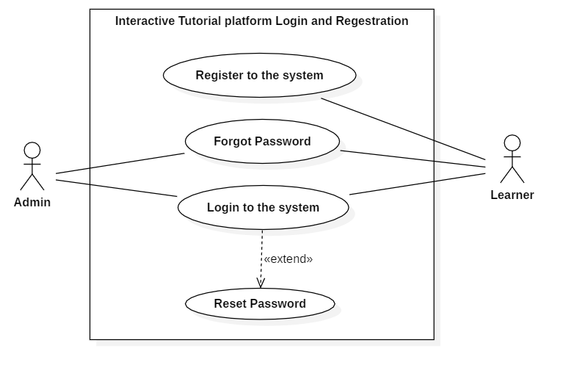

Figure 1: Login and registration

## Learner Profile

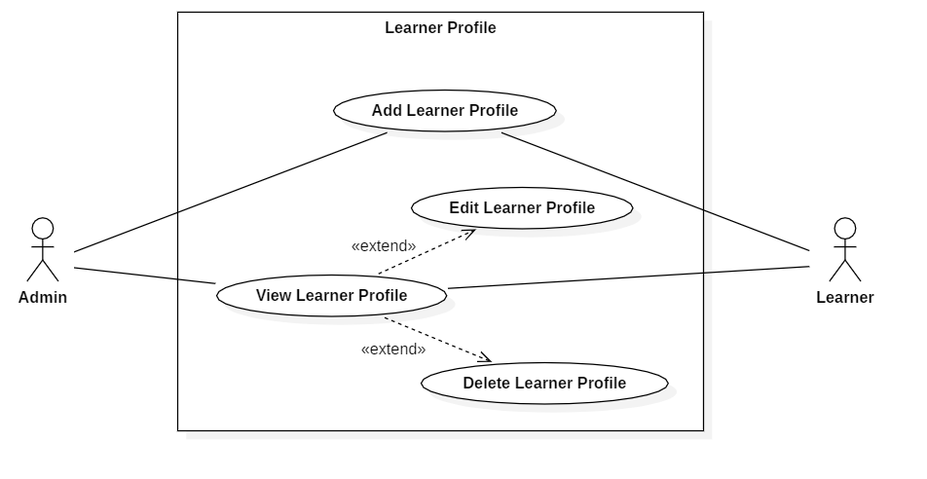

Figure 2: Learner Profile

## Course – Admin

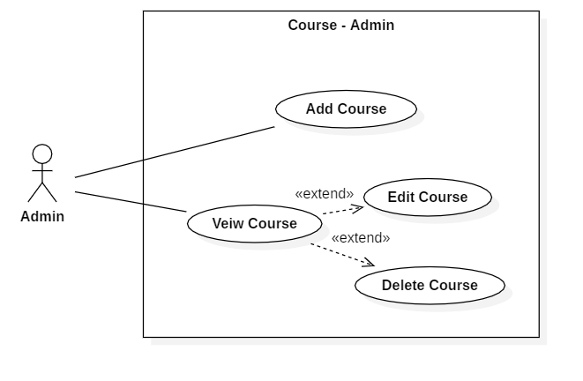

Figure 3: Course - Admin

## Course – Learner

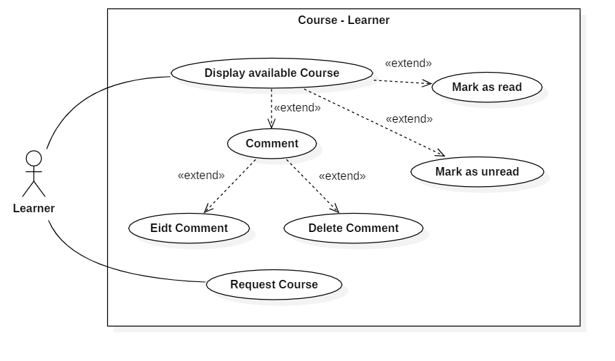

Figure 4: Course – Learner

## Blog

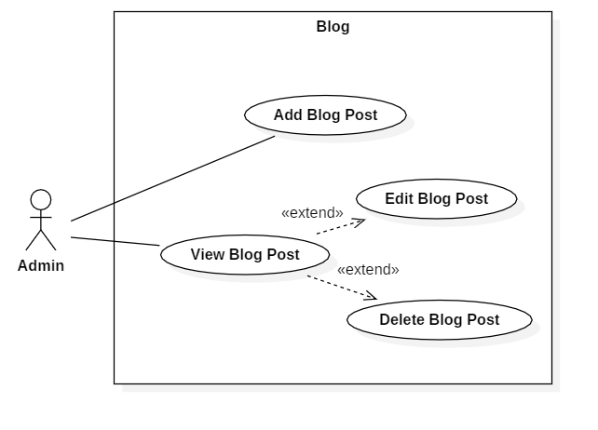

Figure 5: Blog use case

## Issues and Feedbacks

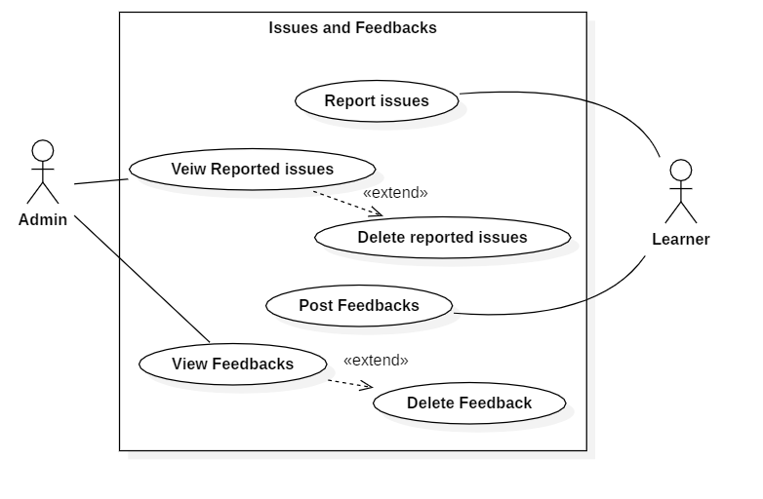

Figure 6: Issues and Feedbacks